**Mongo DB**

Why NoSQL?

* Two most import advantages that NoSQL databases provide i.e., Flexibility, High Scalability.

DBMS – Mongo DB, Couch DB, Orient DB, MySQL, Oracle, Microsoft SQL server.

**MongoDB:**

* In Document Database data is stored in Binary json format.
* Mango DB is one of the most popular document databases and used in popular stacks like MERN and MEAN.
* MongoDB is a NoSQL document database.
* **Use cases** – Gaming, Mobile Application Development, Internet of Things, Real time Analytics.
* **Used By** – Facebook, Google, Linkedin, Microsoft and many more.
* Data is stored in JSON like documents.
* Example:

{

age: 14,

name: “Sree Vardhan”,

}

* Group documents are called a **collection**.
* Each row in table equivalent to Each document in collection.

|  |  |
| --- | --- |
| MySQL | MongoDB |
| Database | Database |
| Table | Collection |
| Row | Document |
| Column | Field |

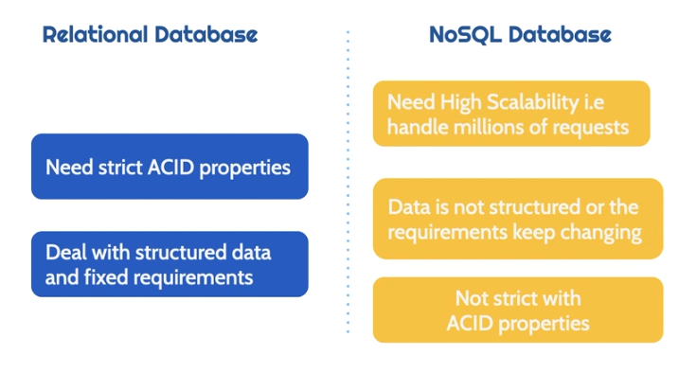

**Getting Started with MongoDB:**

* Setting up MongoDB:
* To get Started with MongoDB and create databases in it, we need to perform the below steps

1. Create MangoDB cluster
2. Install MangoDB shell
3. Connect to MongoDB

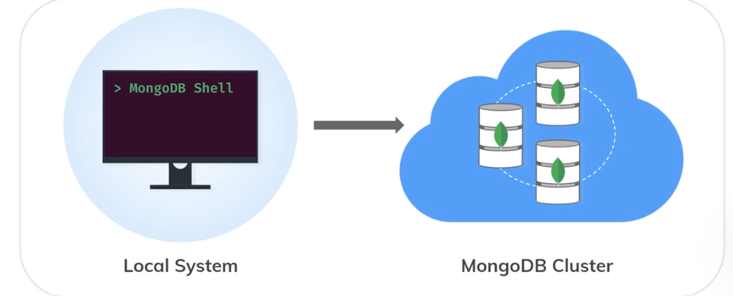

* **mongosh –version:** Run this command in the terminal to check if the MongoDB shell has been successfully installed or not.
* **show databases:** used to show the existing databases.
* **use databaseName:** This command is generally used to switch between databases, any how this will create a new database if it does not exist.
* **db.createCollection(“Name”):** is used to create a collection [similar to table in RDBMS]
* **db,getCollectionNames():** is used to get the existing collection Names.

**Querying MongoDB:**

* **CURD Operations:**

1. 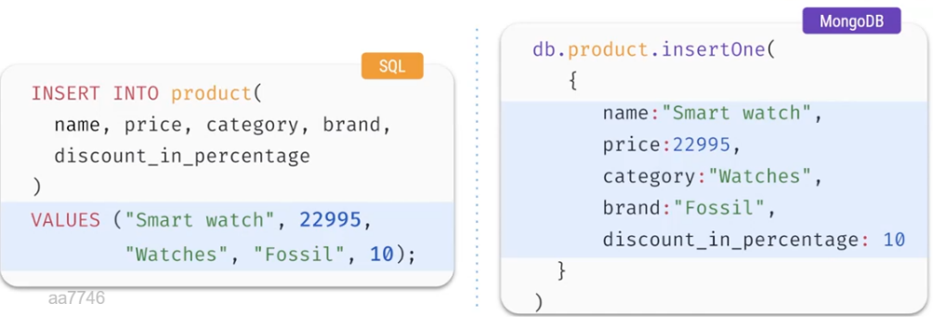**Create:**

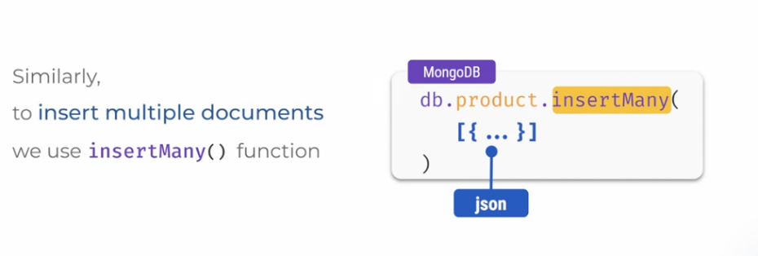

1. **Read:**

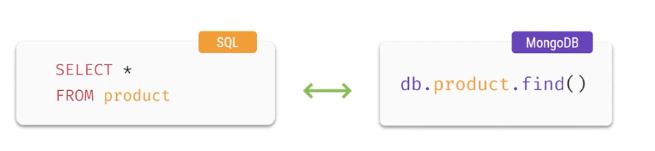

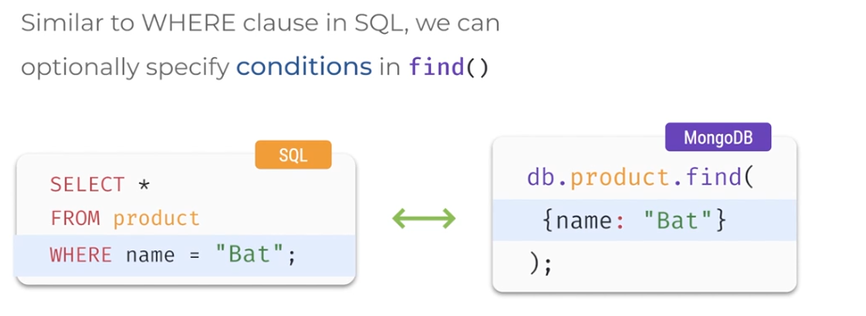

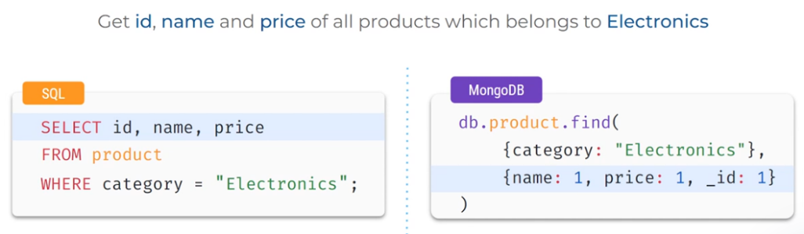

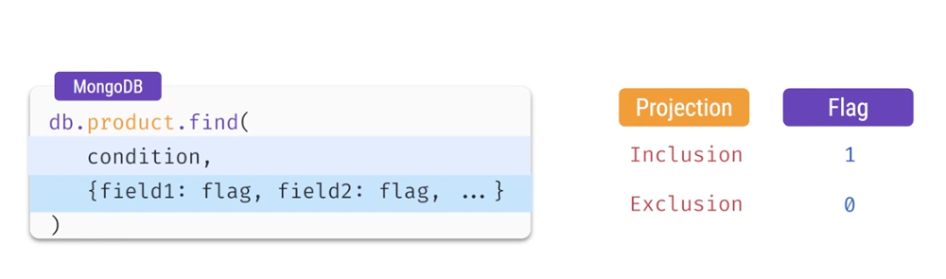

1. **Update:**

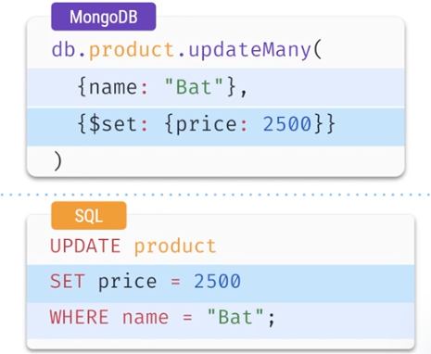

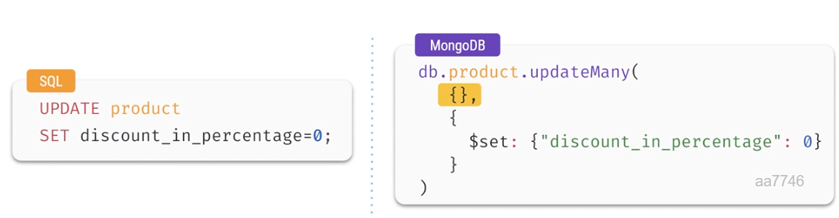All the fields will be will be updated if you won’t specify the condition.

1. **Delete:**

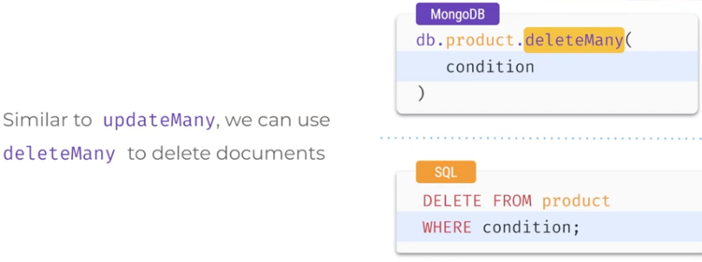

**Comparison operators:**

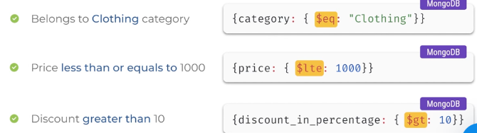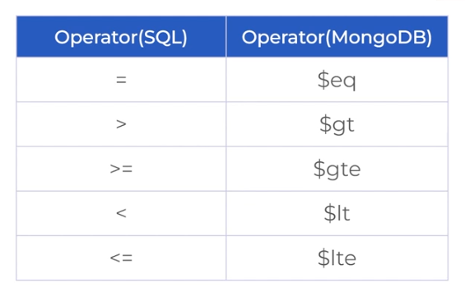

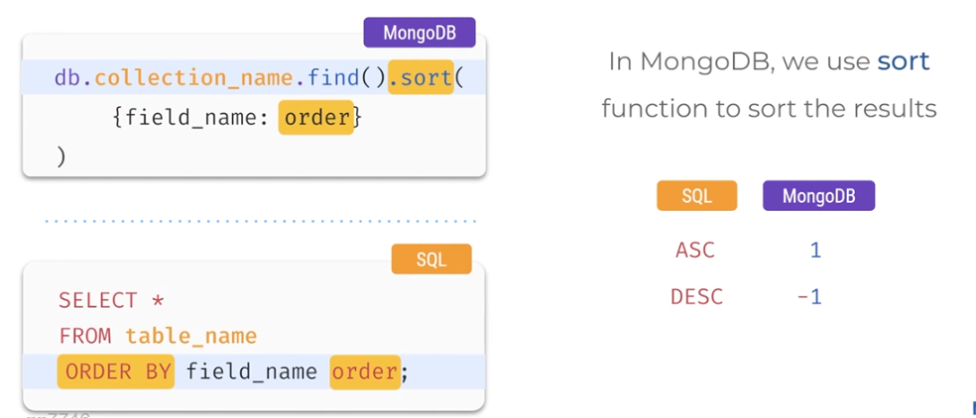**Ordering Results:**

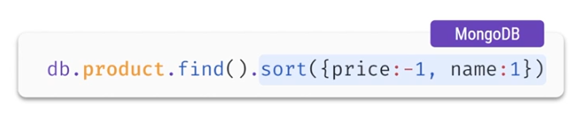

**Pagination:**

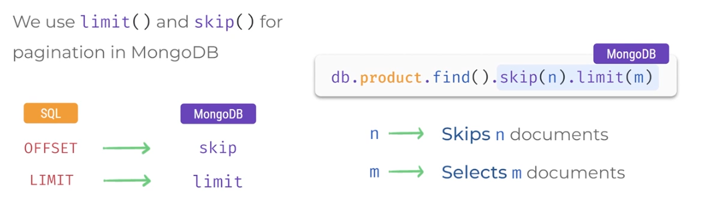

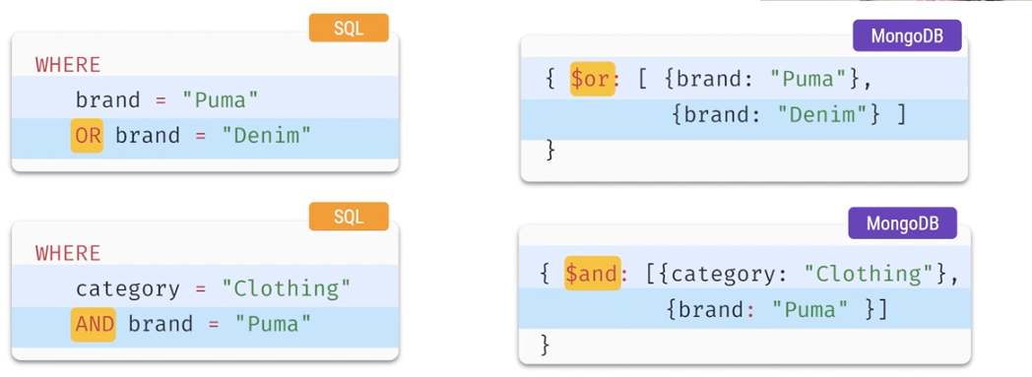**Logical Operators:**

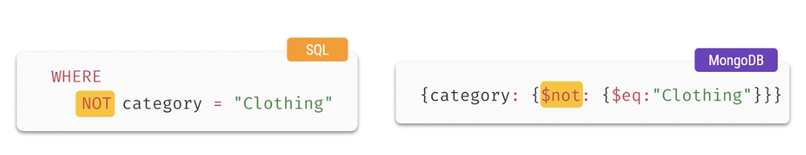

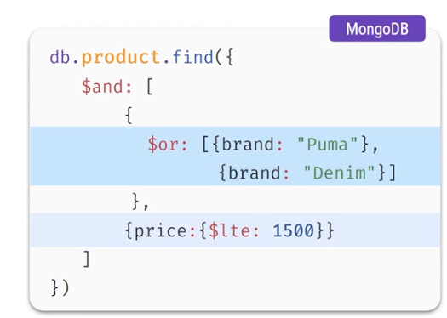**Combination of AND, OR logical operators:**

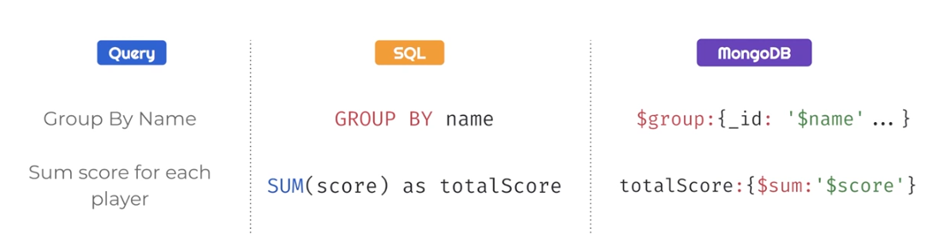**Grouping and Aggregations:**

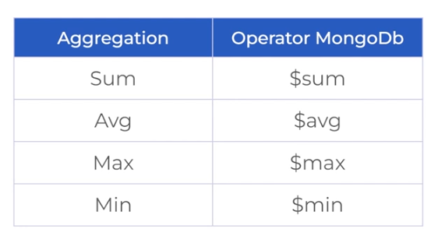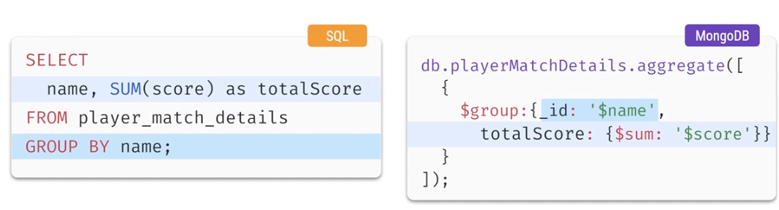

* **Aggregation on Selected Documents:**

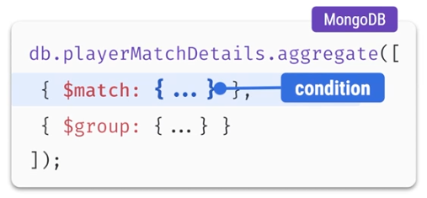

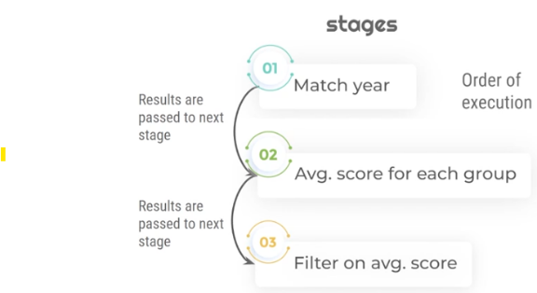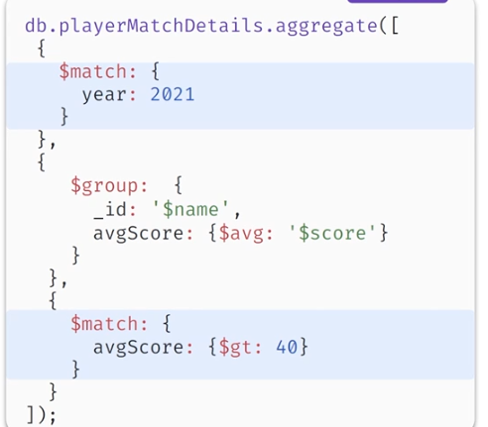Q) Retrieve players whose average score in the year 2021 is greater than 40

**Complex Field Types:**

* **Nested Document / Embedded Document:**

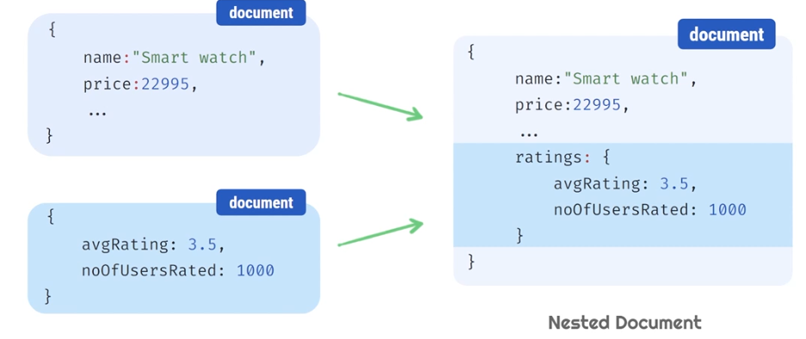

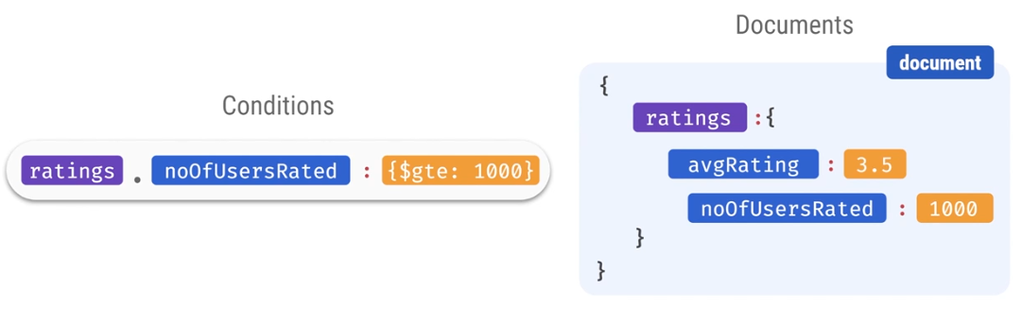

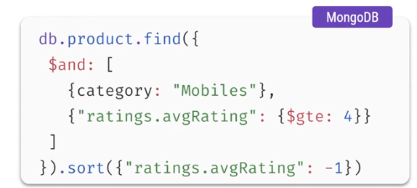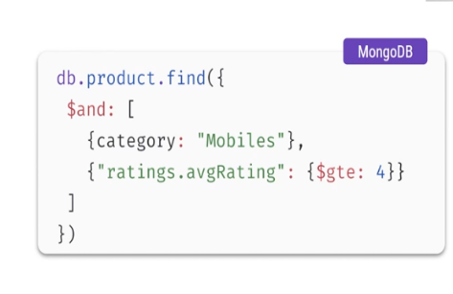

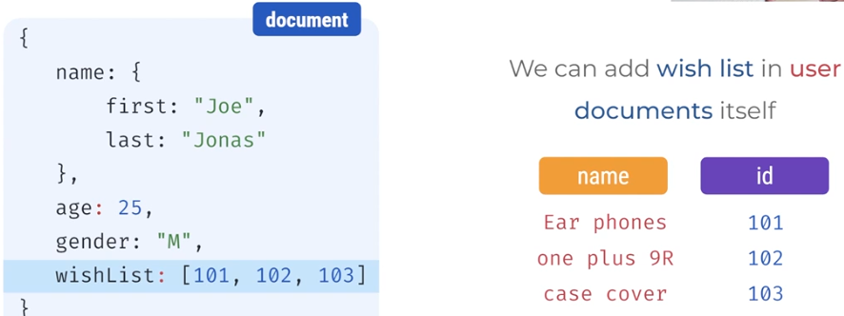**Array Field:**

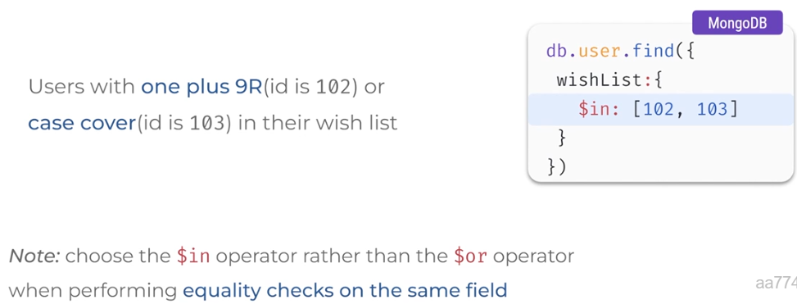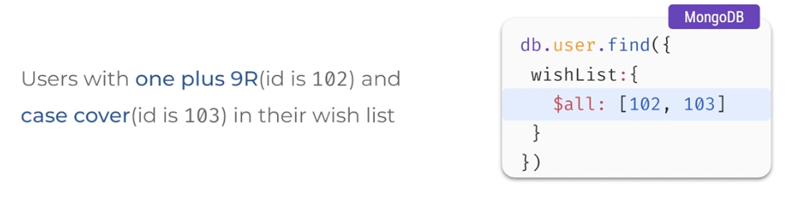Eg:

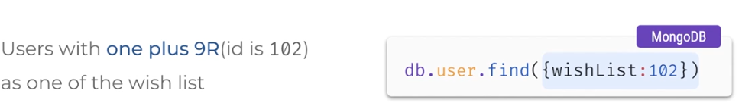

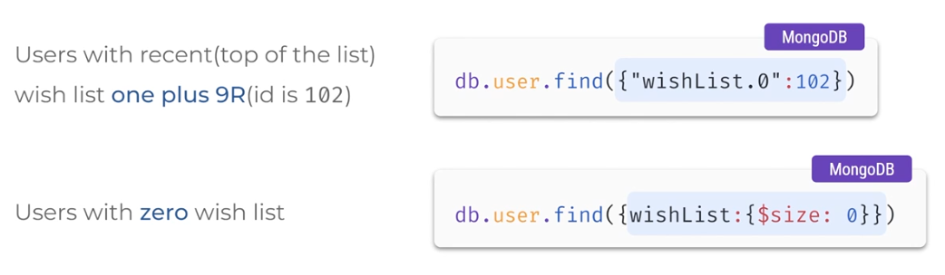

**Array of Nested Documents:**

